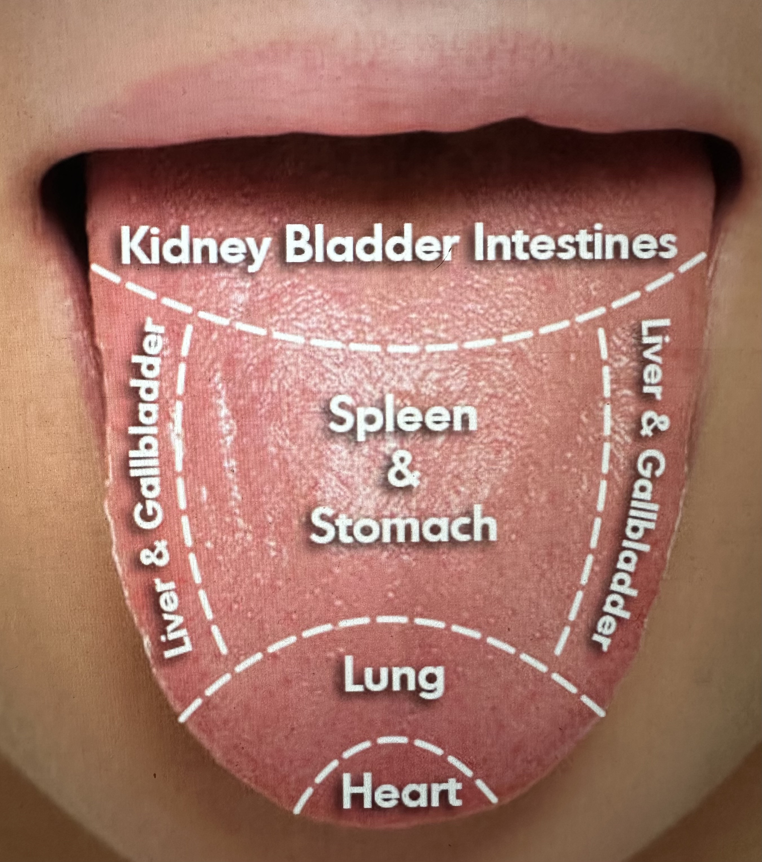
COLOR
Pale:
Pink:
Red:

SHAPE
Thin:
Elongated:
Enlarged:

COATING
White:
Yellow:
Brown/Black:

Moisture/Fissures:
Hydration formula
 ©

